Flask App CI/CD Pipeline with Github & Jenkins
Project Overview
This project demonstrates the implementation of CI/CD pipelines for a Flask application using two approaches:
- Jenkins Pipeline (on a VM or cloud-based Jenkins server).
- GitHub Actions Workflow (cloud-native, integrated with GitHub).
The goal is to automate the build, test, and deployment process, ensuring faster delivery, improved reliability, and secure integration with MongoDB Atlas.

Tech Stack
- Application Framework: Flask (Python)
- Database: MongoDB Atlas (cloud-hosted NoSQL database)
- Testing Framework: Pytest
- CI/CD Tools:
  - Jenkins (Pipeline plugin, GitHub integration, Email notifications)
  - GitHub Actions (workflow automation)
- Version Control: GitHub
- Infrastructure: VM/Cloud server for Jenkins deployment
- Secrets Management:
  - Jenkins Credentials Store
  - GitHub Secrets

Repository Structure
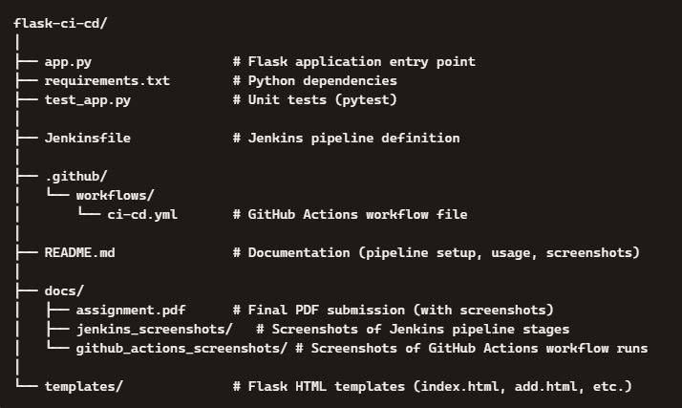
CI/CD Pipeline Architecture
Jenkins Pipeline
- Build Stage: Install dependencies (pip install -r requirements.txt).
- Test Stage: Run unit tests with pytest.
- Deploy Stage: Deploy Flask app to staging environment with MongoDB Atlas connection.
- Triggers: GitHub webhook triggers pipeline on push to main.
- Notifications: Email alerts on success/failure.
GitHub Actions Workflow
- Install Dependencies: Setup Python environment and install requirements.
- Run Tests: Execute test suite with pytest.
- Build: Package application for deployment.
- Deploy to Staging: Triggered on push to staging branch.
- Deploy to Production: Triggered on tagged release.
- Secrets: MongoDB credentials stored securely in GitHub Secrets.

Architecture Diagram (Description)
Imagine the diagram as follows:
- Developer → pushes code to GitHub Repository.
- GitHub triggers:
  - Jenkins Pipeline (via webhook) → runs Build → Test → Deploy stages on Jenkins server.
  - GitHub Actions Workflow → runs jobs (Install → Test → Build → Deploy).
- Both pipelines connect securely to MongoDB Atlas using stored credentials.
- Notifications (Email/Slack) are sent after pipeline completion.

CONTINUOUS INTEGRATION (CI)
Continuous Integration (CI) is the practice of automatically building and testing code every time a developer pushes changes to a shared repository. It ensures that new code integrates smoothly with the existing codebase, reducing bugs and improving software quality.
Key Principles
- Frequent Commits: Developers regularly push code to the main branch.
- Automated Builds: Jenkins or GitHub Actions automatically install dependencies and build the application.
- Automated Testing: Each build triggers unit tests (e.g., using pytest) to validate functionality.
- Immediate Feedback: Developers receive instant notifications (email or Slack) if a build or test fails.
- Version Control Integration: CI tools connect directly to GitHub to monitor commits and pull requests.
Key Points
- app.py → Your Flask app code.
- requirements.txt → List of dependencies (Flask, PyMongo, pytest, certifi, etc.).
- test_app.py → Unit tests for CI/CD validation.
- Jenkinsfile → Declarative pipeline (Build → Test → Deploy).
- .github/workflows/ci-cd.yml → GitHub Actions workflow (Install → Test → Build → Deploy).
- README.md → Explains both pipelines, setup, and submission instructions.
- docs/assignment.pdf → Final submission file with screenshots.
- docs/screenshots → Organize Jenkins and GitHub Actions screenshots separately for clarity.

Fork the Source Code from GitHub Repo and Configurations
1. Fork the Repository
- Navigate to the original Flask application repository: https://github.com/mohanDevOps-arch/flask_Practice.git
- Click Fork (top-right corner) to create your own copy under your GitHub account.
- This forked repository will serve as your working project for CI/CD setup.

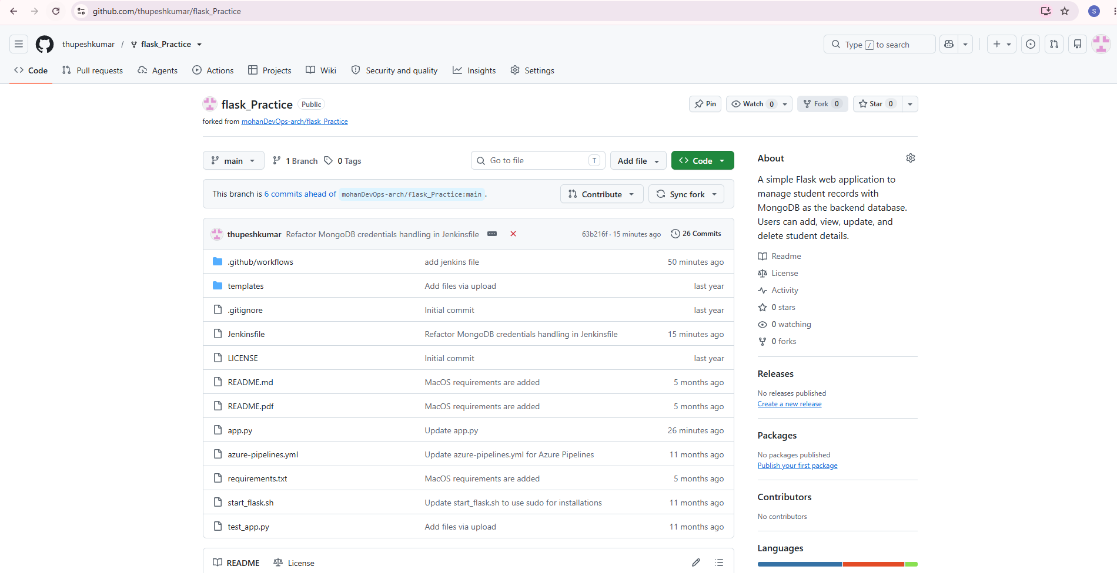
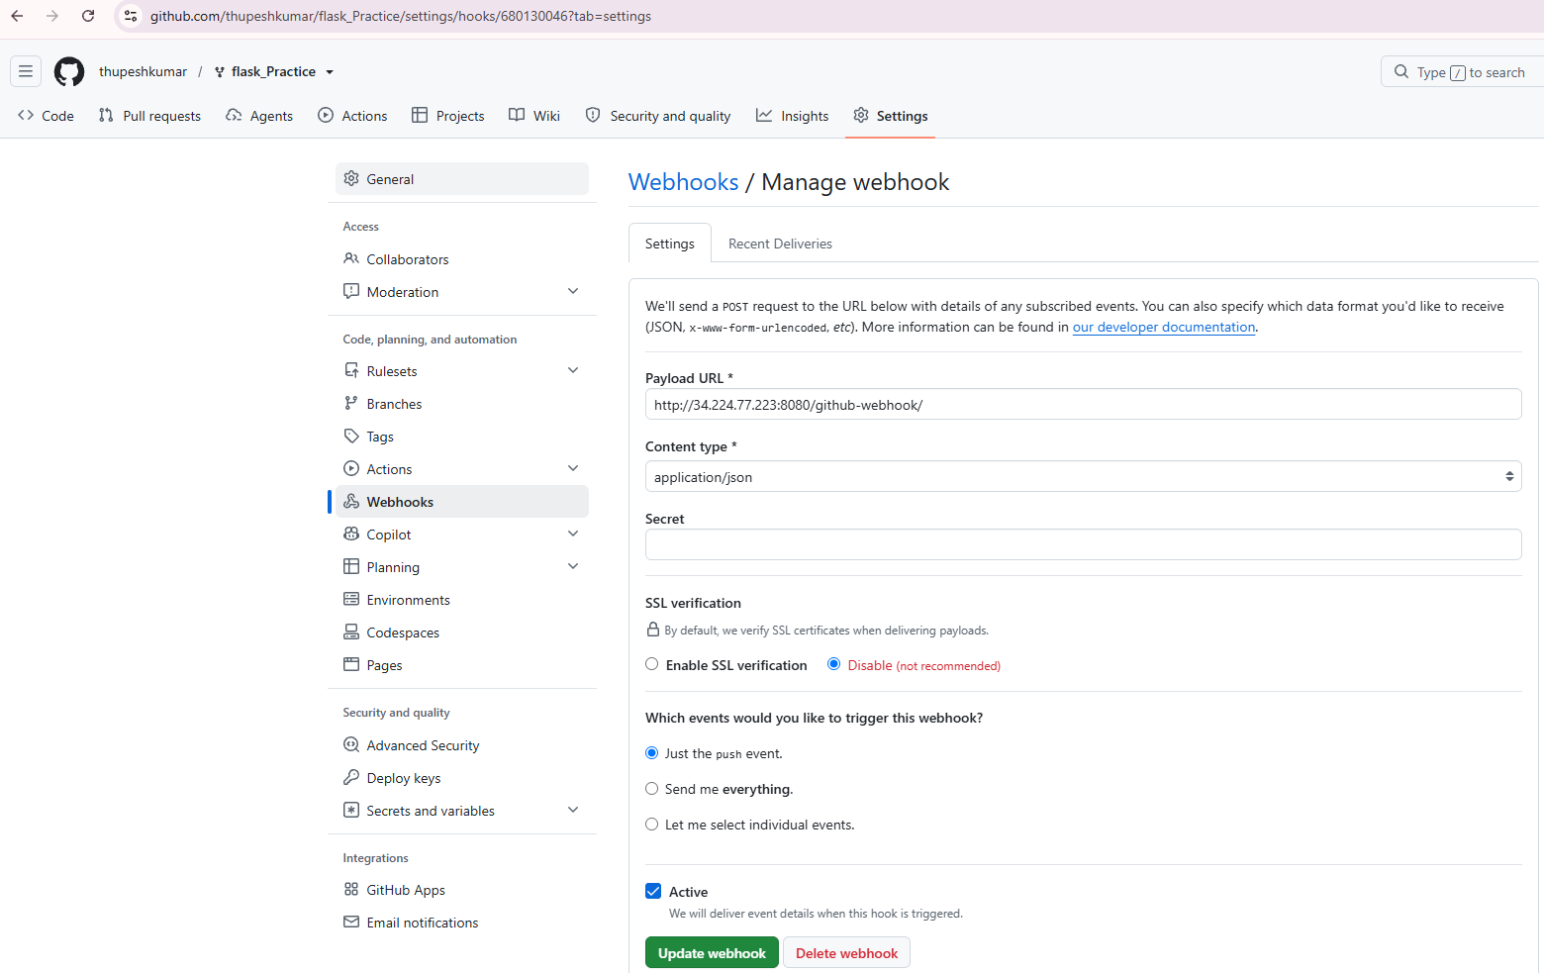
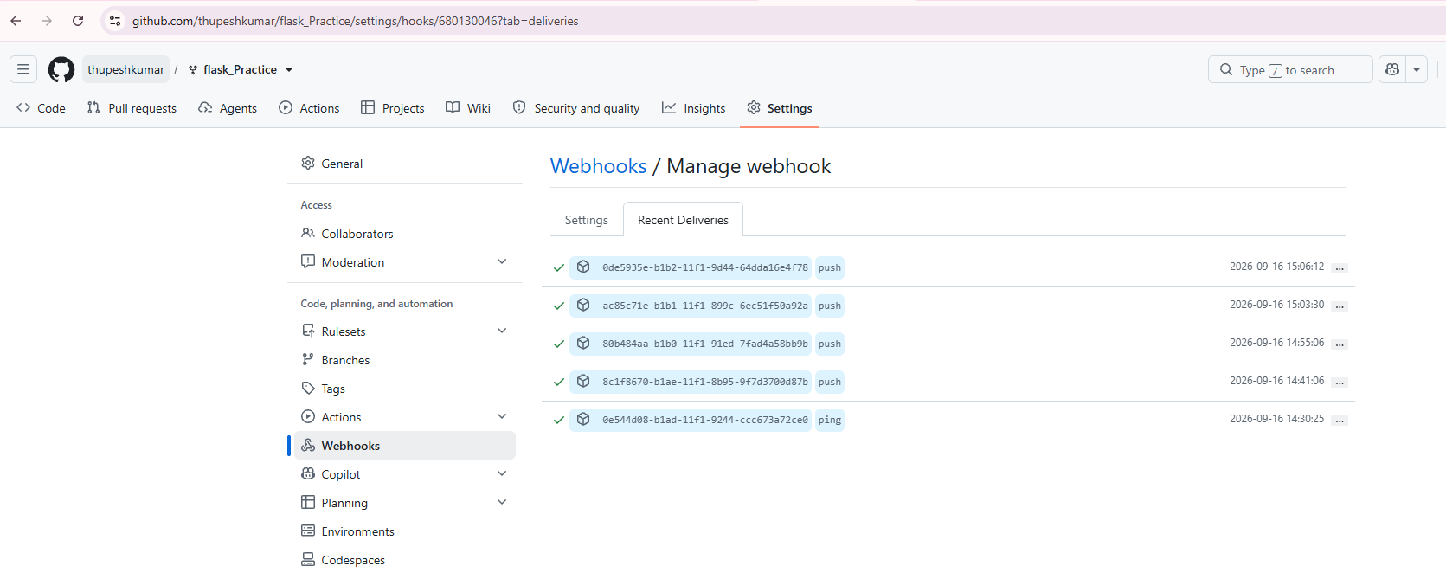

Jenkins Configuration
- Install required plugins:
  - Pipeline
  - GitHub Integration
  - Email Extension
- Create a new pipeline job:
  - Source: your forked GitHub repo.
  - Script path: Jenkinsfile.
- Add a GitHub webhook:
  - URL: http://34.224.77.223:8080/github-webhook/
  - Trigger: Push events.

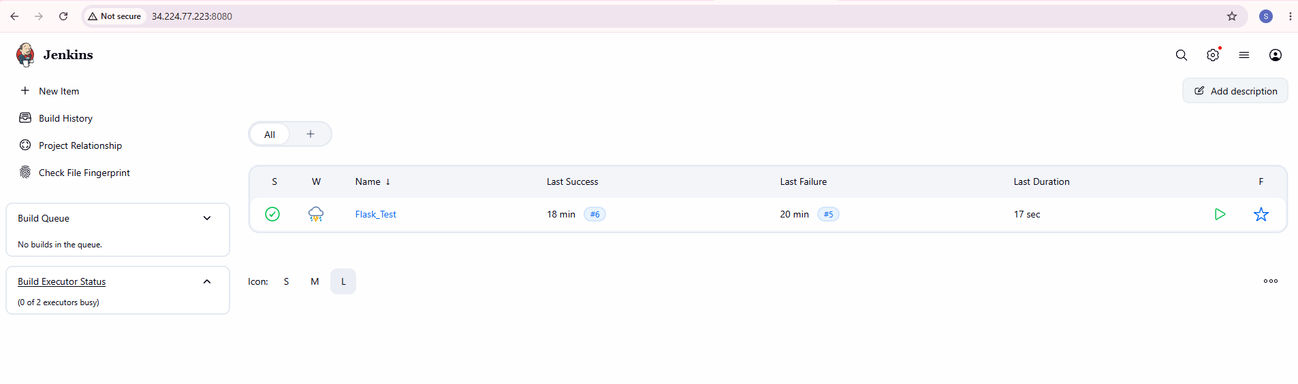

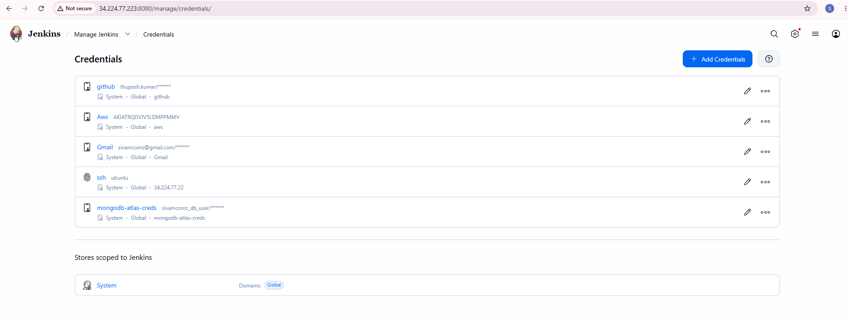
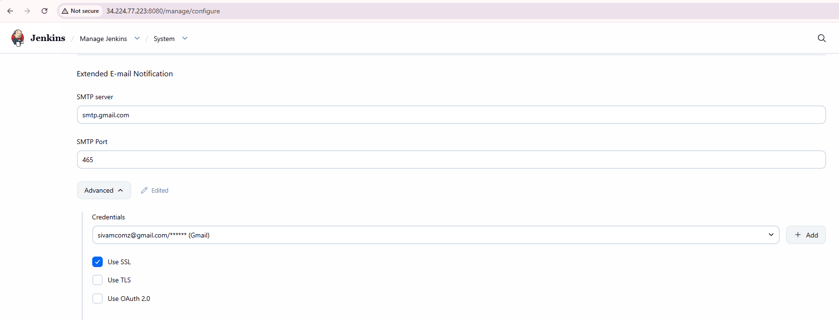
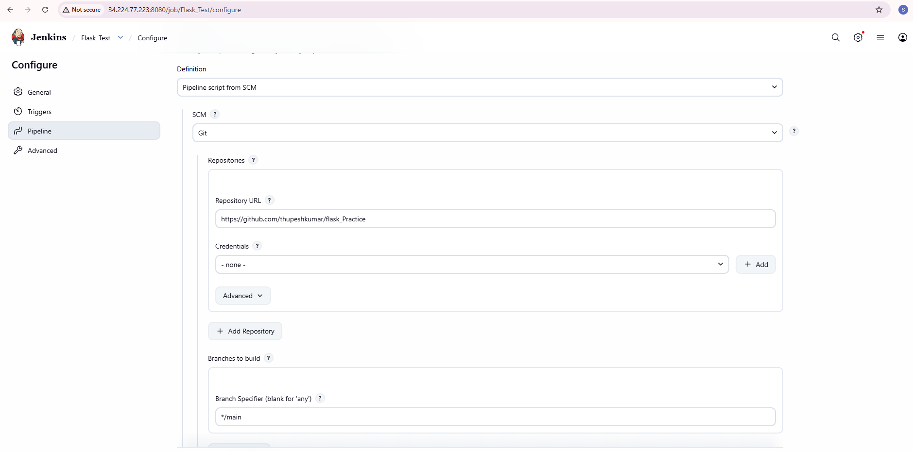

Build Pipeline Now
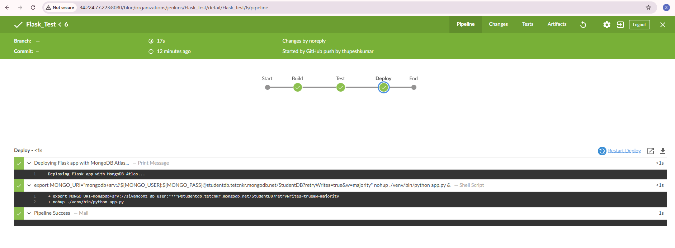

HOW TO RUN TESTS LOCALLY
# Create virtual environment
python -m venv venv

# Activate environment
# Windows:
venv\Scripts\activate

# Mac/Linux:
source venv/bin/activate

# Install dependencies
pip install -r requirements.txt

# Run tests
pytest -v

git clone https://github.com/Saima-Devops/Flask-App-CI-CD-Pipeline.git
cd Flask-App-CI-CD-Pipeline
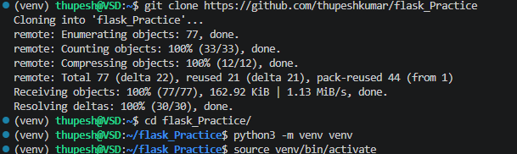

Connect with MongoDB and get the URI
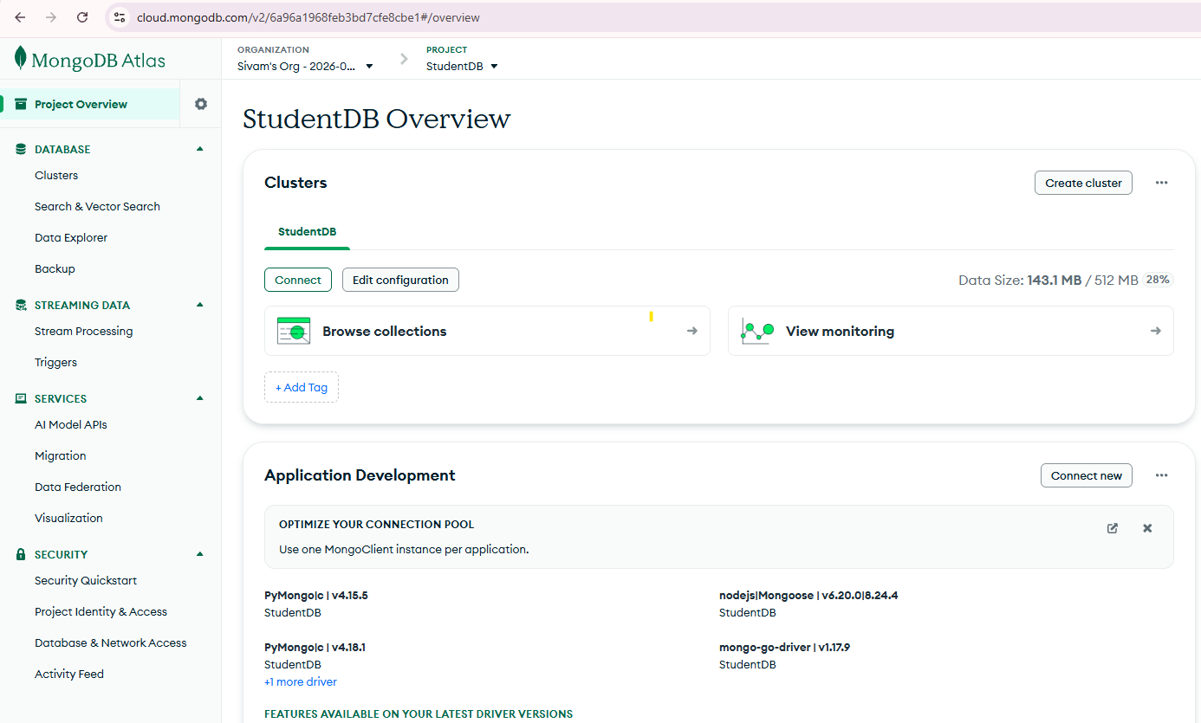
Set Environment Variables
Create .env file:
MONGO_URI=<your mongodb_connection_string_here>

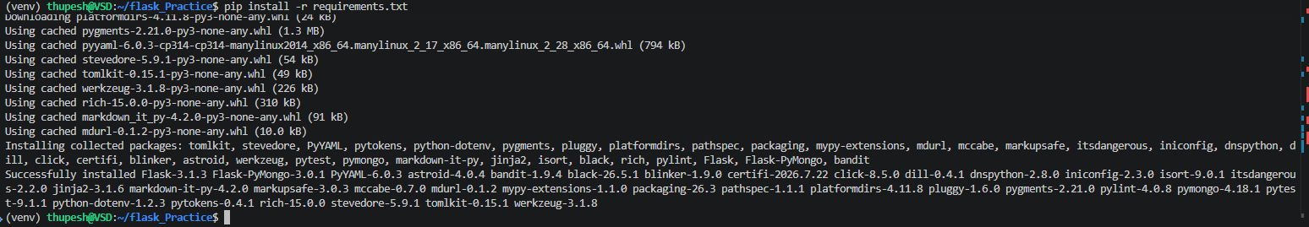

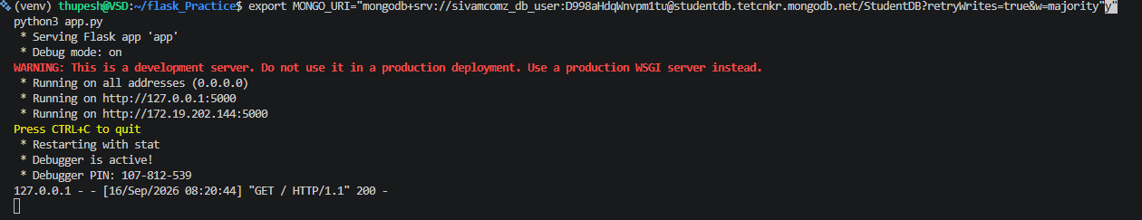

Run the App locally & check its functionality

